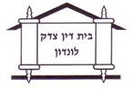
London Beth Din
Arbitration/Din Torah
Application form
Name(s) of Applicant

Address

Daytime telephone contact numbers and email address

Name(s) of proposed defendant(s)

Address of proposed defendant(s)

Daytime telephone contact numbers and email address of proposed defendant(s)

Nature of the claim

Relief sought

Please note that this application should be accompanied by a deposit cheque for the sum of £100 payable to USKB. Alternatively, please contact the LBD office on to make a payment over the phone or pay by BACS transfer (Sort Code 60-80-07, Account number 54160537).

